

Customer Insights & Campaign Analytics – Dunnes Stores
Comprehensive Customer Analytics Case Study
Built by Amruth Raj • 2025

Table of Contents
1. Executive Summary
2. Project Introduction
3. SQL Data Pipeline
4. Methodology & Data Preparation
5. Tableau Dashboards
6. Insights & Recommendations
7. SQL Pipeline
8. Key Takeaways

1. Executive Summary
This case study presents a complete customer analytics project developed for Dunnes Stores Ireland, designed to help the business better understand its customer base, evaluate purchasing and engagement behaviours, and assess marketing campaign performance.
Using a combination of SQL for data preparation, feature engineering, and segmentation, followed by interactive Tableau dashboards, this analysis uncovers actionable insights that support data-driven decision-making across marketing, CRM, and customer strategy teams.
The project evaluates three core analytical areas:
1. Customer Demographics & Geographic Distribution
An assessment of who Dunnes customers are including age, education, household composition, and global presence. Customers are found to be highly educated, financially stable, and primarily aged 40–60, with strong representation across Spain, Canada, Saudi Arabia, and India.
2. Customer Spend, Engagement, and Tenure Behaviour
Analysis reveals clear behavioural patterns where higher education levels and longer tenure correlate with stronger spending and more consistent engagement. Dormant customers, despite lower frequency, still show strong spending capability — indicating meaningful re-engagement opportunity.
3. Marketing Campaign Response & Revenue Impact
Campaign response behaviour shows that active customers and customers with higher education deliver the best conversion rates. Responders generate 82% more spend per customer compared to non-responders, demonstrating strong ROI potential.
This end-to-end analytical workflow represents the type of production-ready analytical toolkit expected in business analytics roles, showcasing skills in SQL, data engineering, segmentation modelling, dashboard design, and insight generation.

2. Project Introduction

2.1 Business Context
Dunnes Stores is one of Ireland’s largest and most established retail chains, serving a diverse customer base across grocery, fashion, and household categories. As competition increases and customer expectations continue to evolve, understanding customer behaviour and campaign performance has become essential for driving personalised engagement and improving marketing ROI.
With access to large volumes of customer, transaction, and campaign interaction data, Dunnes Stores has the opportunity to implement a data-driven customer insights framework that supports:
- Better segmentation
- Targeted campaign design
- Customer lifetime value (CLV) optimisation
- Improved customer retention
- Higher marketing efficiency
This project simulates a real-world internal analytics initiative where the analytics team builds a complete customer insights engine using SQL, Tableau, and structured methodology.

2.2 Objective of the Analysis
The core objective of this project is to perform an end-to-end customer analytics study to answer the following business questions:
Customer Understanding
- Who are Dunnes Stores’ customers?
- What demographic and household characteristics define them?
- Which countries or regions show the strongest customer base?
Behavioural & Spend Patterns
- How do customers engage with the store across channels?
- How does tenure, recency, and education affect spending?
- What segments generate the most value?
Campaign Effectiveness
- How effective are past marketing campaigns?
- Which customer segments respond the most?
- What is the spending difference between responders and non-responders?
Strategic Impact
- Which segments should Dunnes Stores prioritise?
- Where are the biggest opportunities for growth, retention, or reactivation?

2.3 Dataset Summary
The dataset contains customer-level information across demographics, spending behaviour, household details, engagement metrics, and marketing campaign responses.
Key data categories include:
- Demographics: Year of birth, education, marital status, country
- Household: Number of children and teens
- Financials: Household income
- Behaviour: Purchases across store, catalog, and web
- Engagement: Web visits, recency, tenure
- Marketing Response: Five historical campaigns + latest response
- Spending: Category-level spend (wines, fruits, meat, sweets, etc.)
Dataset Size:
2,206 customers (after cleaning and filtering)

2.4 Tools & Technologies Used
Tool | Purpose
SQL (MySQL) | Data extraction, cleaning, validation, feature engineering
Tableau | Interactive dashboard creation and visual analytics
Excel/CSV | Initial data exploration

2.5 Key Metrics & KPIs
Customer Metrics
- Age
- Income
- Tenure
- Recency
- Total Spend
- Total Purchases
Engagement Metrics
- Web Visits per Month
- Store vs Catalog vs Web purchase mix
- Activity Segments (Active, Warm, Dormant)
Campaign Metrics
- Response rate
- Prior vs current campaign acceptance
- Campaign responder segments
- Spend difference between responders/non-responders

3. SQL Data Pipeline

3.1 Raw Data Understanding
The SQL workflow begins with exploring the raw customers dataset to verify structure, content, and completeness:
- Sample row inspection (SELECT * LIMIT 10)
- Row count validation
- Column-level metadata review (DESCRIBE customers)
- Identifying data types for all fields
- Checking for missing values in key fields
- Scanning for invalid or unexpected category values
- Ensuring customer IDs are unique (duplicate check)
These checks confirm the dataset’s readiness for transformation and guide the upcoming cleaning steps.

3.2 Data Quality Checks
A series of structured validation queries ensured data integrity:
Missing Value Identification
- Year of birth
- Education
- Income
- Customer join date
This helps determine whether rows require cleaning or exclusion.
Category Validation
Distinct value scans were performed for:
- Education
- Marital status
- Country
This ensures values are standardised and consistent for downstream segmentation.
Range Validations
- Age distribution based on year of birth
- Income buckets (to detect unrealistic values)
- Recency min/max/average
- Campaign response values strictly 0/1
Any outliers or invalid entries were flagged for correction or filtering.

3.3 Data Cleaning Steps
Based on the results of data quality checks, cleaning rules were applied:
Age Filtering: Customers outside the range 18–90 years were excluded to maintain demographic relevance.
Income Filtering: Records with income outside €5,000–€250,000 were removed to ensure financial plausibility.
Marital Status Standardisation: Irregular categories such as “Alone”, “YOLO”, and “Absurd” were reclassified under a unified “Other” group.
Null Handling: Customers missing essential demographic fields were removed or corrected depending on severity.
These cleaning steps produced the customers_cleaned1 dataset, a reliable foundation for enrichment.

3.4 Feature Engineering
This phase transforms raw fields into meaningful analytical features commonly used in customer insights work.
Age Calculation
Age = 2025 − Year_Birth
Tenure Calculation
Customer tenure measured as the number of years since joining:
TIMESTAMPDIFF(YEAR, Dt_Customer, CURDATE())
Total Spending
Sum of all product category spending:
- Wines
- Fruits
- Meat
- Fish
- Sweets
- Gold products
Total Purchases
Total store, catalog, and web purchases combined.
Household Size
Total_Kids = Kidhome + Teenhome
Campaign Aggregation
Total_Accepted_Campaigns = AcceptedCmp1 + … + AcceptedCmp5
These engineered fields were added to the customers_enriched1 table.

3.5 Customer Segmentation Logic
The enrichment layer introduces segmentation fields used throughout the dashboards:
Recency Buckets
- Active: ≤ 30 days
- Warm: 31–90 days
- Dormant: > 90 days
Responder Classification
- Responder: Latest campaign response = 1
- Non-Responder: Latest campaign response = 0
Campaign Response Type
- Repeat Responder: Previously responded + responded now
- New Responder: First-time response
- Previously Engaged: Responded before but not now
- Never Engaged: No responses across all campaigns
Ever Accepted Flag
Binary indicator capturing customers who accepted any past campaign.
These segments enable advanced behavioural analysis and storytelling.

3.6 Final Dataset Used for Dashboarding
After all cleaning and enrichment steps, the final curated dataset contained:
- 2,206 valid customers
- Fully engineered features
- No missing or inconsistent values
- Clean demographic, financial, and behavioural fields
- Marketing performance fields
- Segmentation attributes
This dataset was exported and connected to Tableau, where three analytical dashboards were built:
- Customer Demographics & Geographic Profile
- Customer Spend, Engagement & Tenure Insights
- Marketing Campaign Response & Customer Value Analysis

4. Methodology & Data Preparation
This section outlines the structured, end-to-end methodology used to transform the raw customer dataset into a clean, enriched, analytics-ready model for dashboarding and insights. The workflow mirrors the standards followed by analytics and BI teams in data-driven retail organisations like Dunnes Stores.

4.1 Data Quality Assessment
Before performing any transformation or analysis, a full data quality review was conducted across all fields in the raw dataset. The assessment focused on four core areas:
1. Completeness
Checked for missing values in:
- Year of birth
- Income
- Education
- Customer join date
- Campaign response fields
These fields are foundational to segmentation and demographic analysis.
2. Validity
Evaluated whether category fields contained acceptable and expected values:
- Education levels
- Marital status categories
- Country codes
- Response fields (0/1 only)
3. Consistency
Ensured fields aligned logically:
- Age must match the year of birth
- Purchase counts must be non-negative
- Recency values must align with tenure and join date
4. Outlier Detection
Identified and addressed:
- Unreasonably high or low incomes
- Implausible ages outside 18–90
- Extreme recency or tenure values
This assessment ensured a stable foundation before cleaning.

4.2 Data Cleaning Approach
After assessing data quality, a set of systematic cleaning rules was applied:
Age Filtering
- Customers below 18 or above 90 were removed.
Income Filtering
- Restricted to €5,000–€250,000 to maintain realistic spending power representation.
Marital Status Normalisation
- Mapped inconsistent labels (e.g., “YOLO”, “Alone”, “Absurd”) into a unified “Other” category.
Null Handling
- Records with essential demographic or financial data missing were removed.
- Non-critical fields were imputed or left as-is.
Duplicate Removal
- No duplicates were found based on customer ID.
After cleaning, the dataset was reduced to 2,206 high-quality customer records, suitable for reliable analysis.

4.3 Feature Dictionary
A full feature dictionary was created to document the new engineered fields:
Feature | Definition | Purpose
Age | Calculated as 2025 - Year_Birth | Standardised demographic metric
Tenure_Years | Years since customer joined Dunnes | Indicates loyalty/retention time
Total_Spend | Sum of all category-level spending fields | Measures overall customer value
Total_Purchases | Sum of web, catalog, and store purchases | Highlights multi-channel engagement
Total_Kids | Kidhome + Teenhome | Household overview
Total_Accepted_Campaigns | Sum of all campaign acceptance flags | Captures historical engagement
Recency_Bucket | Active/Warm/Dormant segmentation | Used for behaviour-based campaigns
Is_Responder | Whether customer responded to latest campaign | Simplifies response analysis
Campaign_Response_Type | Repeat/New/Previously Engaged/Never Engaged | Explains long-term behavioural patterns
Ever_Accepted | Binary flag for historical campaign acceptance | Identifies previously engaged customers
This dictionary ensures clarity for future stakeholders and reproducibility.

4.4 Segmentation Logic
Segmentation is central to understanding customer behaviour. Three key segmentation models were implemented:
1. Recency Segmentation
Based on recency (days since last purchase):
- Active: ≤ 30 days
- Warm: 31–90 days
- Dormant: > 90 days
This allows targeting customers based on current engagement state.
2. Campaign Response Segmentation
Based on historical campaign interactions:
- Repeat Responder
- New Responder
- Previously Engaged
- Never Engaged
Helps identify responsiveness trends and customer loyalty signals.
3. Value-Based Segmentation
Derived from:
- Total spend
- Tenure
- Campaign acceptance history
Supports differentiating between high-, medium-, and low-value customers.
These segmentation layers were intentionally designed to support both marketing strategy and predictive modelling.

4.5 Processing Workflow Diagram

Below is the conceptual workflow used throughout the project:
Raw Customer Data
│
▼
Data Quality Assessment
(Missing, Outliers)
│
▼
Data Cleaning Layer
(Fix categories, remove invalids)
│
▼
Feature Engineering Layer
(Spend, Tenure, Recency, Segments)
│
▼
Enriched Customer Model
│
▼
Tableau Dashboard Development
│
▼
Insights & Recommendations
This represents the end-to-end transformation pipeline from ingestion to insights.

4.6 Final Modelling Flow
Following cleaning, validation, and enrichment, the final dataset was fully prepared for dashboarding. The final dataset offers:
- Reliable demographics
- Complete financial metrics
- Well-structured behavioural fields
- Clear marketing response indicators
- Actionable segmentation attributes
This modelling flow ensures the data was 100% ready for advanced analytics and dashboard storytelling.

5. Tableau Dashboards
This section presents the interactive dashboards developed in Tableau using the final enriched customer dataset. The dashboards are designed to provide a clear, intuitive understanding of customer demographics, engagement trends, and marketing performance. Each dashboard answers specific business questions and contributes to the overall strategic recommendations.
High-resolution screenshots of each dashboard are included below, along with short explanations to guide interpretation.

5.1 Customer Demographics & Geographic Profile
Business Purpose
To understand who Dunnes Stores’ customers are and where they are located. Demographic segmentation provides a foundational view of customer behaviour and serves as a basis for campaign targeting.
Key Views in the Dashboard
- Customer Overview Summary – Total customers, average age, average income, and household composition.
- Customer Age Distribution – Shows a concentration of customers in the 40–60 age range.
- Marital Status Distribution – Highlights that most customers are married or cohabiting.
- Preferred Product Categories – Visual breakdown of category-level spending.
- Geographic Presence – World map showing customer distribution across major countries.
Dashboard 1: Customer Demographics & Geographic Profile
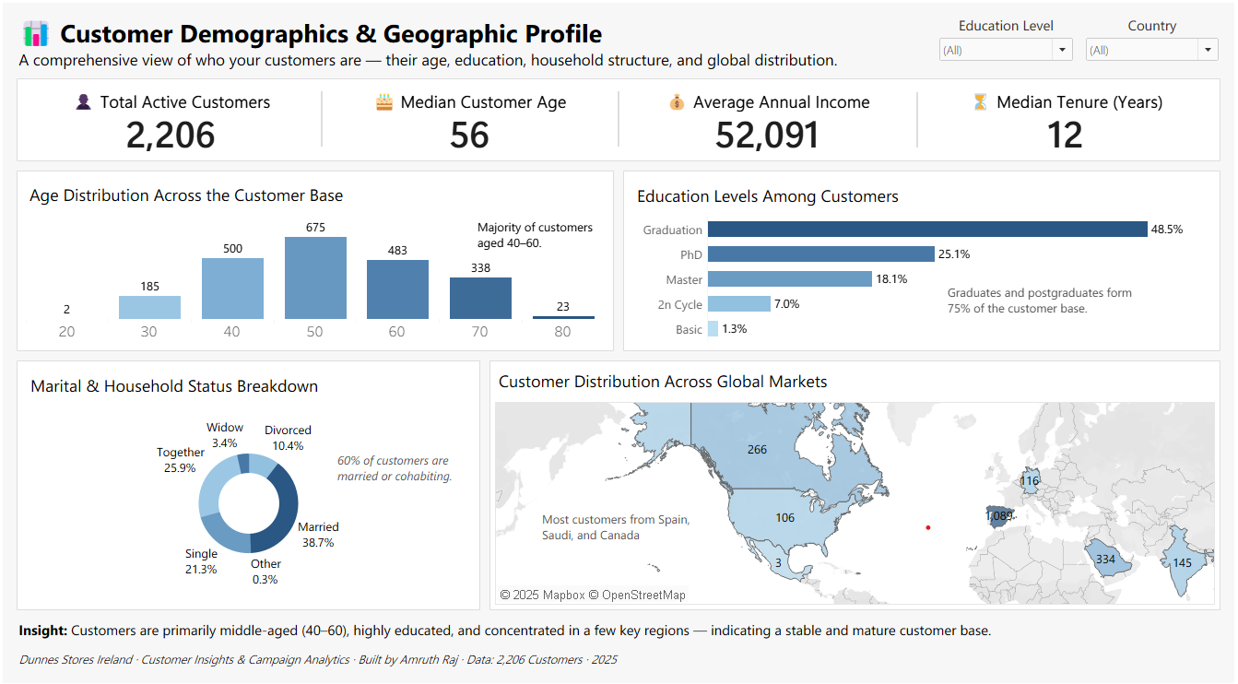
Key Insights
- Customer base is relatively mature, with a median age of 56.
- Graduates and postgraduates form the majority of customers.
- Customers from Spain, Saudi Arabia, and Canada represent a significant share of the international segment.
- Households with children show modest purchasing, while adult households drive higher spend.

5.2 Customer Spend, Engagement & Tenure Insights
Business Purpose
To understand how customers spend and engage across channels and whether tenure correlates with higher loyalty or spending. This dashboard helps identify high-value behavioural segments.
Key Views in the Dashboard
- Average Spend by Education – Highlights spending power by qualification.
- Average Spend by Recency Segment – Compares Active, Warm, and Dormant customers.
- Customer Tenure vs Purchases – Shows how long-term customers behave.
- Average Web Visits by Recency – Measures digital engagement.
- Spend by Country – Helps identify high-value markets.
Dashboard 2: Customer Spend, Engagement & Tenure Insights
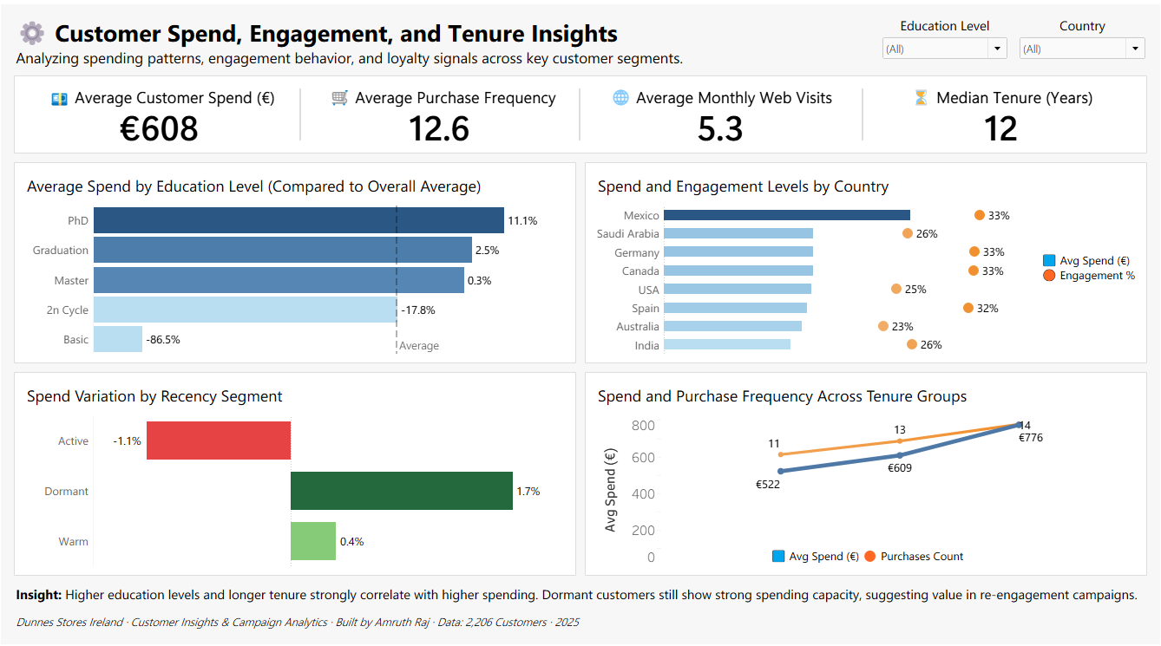
Key Insights
- PhD and Graduate customers spend above average.
- Dormant customers, despite low recency, still show higher-than-average spending → strong reactivation potential.
- Engagement varies widely by geography, with Mexico, Saudi Arabia, and Germany consistently outperforming others.
- Longer-tenure customers show higher total purchases, indicating loyalty-driven value.

5.3 Marketing Campaign Response & Customer Value Analysis
Business Purpose
To evaluate the effectiveness of past marketing campaigns and identify which customer segments are most responsive. This helps refine targeting strategies and maximise marketing ROI.
Key Views in the Dashboard
- Overall Response Rate (KPI Card)
- Response Rate by Education
- Response Rate by Marital Status
- Response Rate by Country
- Spend Comparison: Responders vs Non-Responders
- Campaign Response Type Segmentation
- Recency Segment Response Analysis
- Campaign Acceptance Distribution Table

Dashboard 3: Marketing Campaign Response & Customer Value Analysis
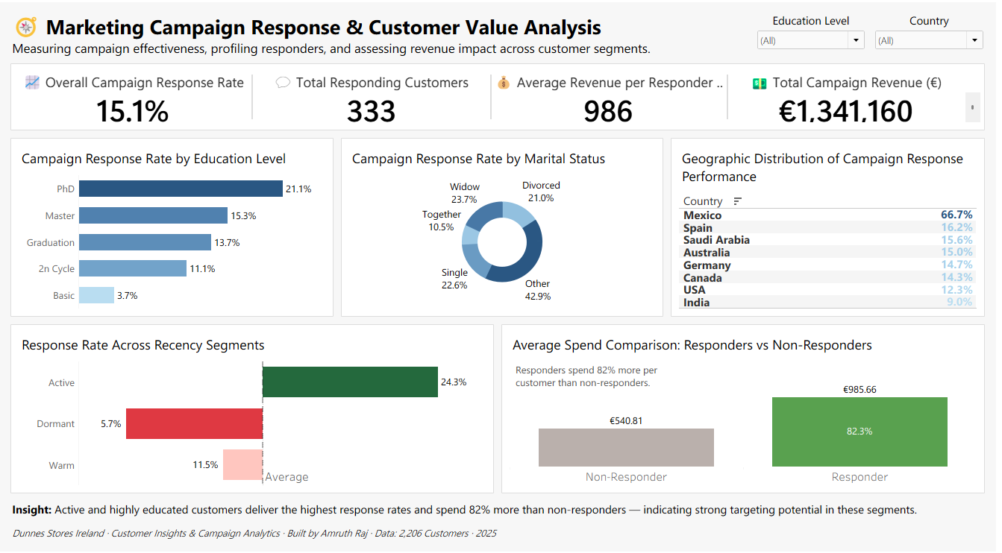
Key Insights
- Overall campaign response rate is 15.1%, with PhD customers (21.1%) leading in conversions.
- Responders spend 82% more than non-responders → high ROI opportunity.
- Customers in Mexico show exceptionally strong response rates.
- Active customers demonstrate the highest responsiveness (24.3%), followed by Warm customers.
- “Never Engaged” customers represent the majority, showing untapped potential with tailored messaging.

6. Insights & Recommendations
This section brings together the findings from demographic, behavioural, and campaign analyses to highlight the most important insights for Dunnes Stores. The goal is to translate data into clear business actions that support customer growth, engagement, and retention.

6.1 Key Insights
Insight 1 — The Dunnes customer base is mature, highly educated, and financially strong.
Most customers fall between 40–60 years, with a median age of 56.
Nearly 75% hold graduation or postgraduate degrees, and the average household income is €52,091.
This demographic profile indicates customers who are:
- Comfortable with discretionary spending
- Receptive to value-driven messaging
- Likely to purchase premium categories

Insight 2 — Spending increases significantly with higher education and longer tenure.
Customers with PhD or Graduation backgrounds consistently spend 8–12% above average.
Tenure plays an important role — customers with 12+ years of history with Dunnes show markedly higher purchasing.
This suggests:
- Strong brand loyalty
- High Customer Lifetime Value (CLV)
- Opportunities for exclusive loyalty campaigns

Insight 3 — Dormant customers still hold strong spending potential.
Although Dormant customers (recency > 90 days) show lower visit frequency, they still spend above the average customer spend.
This is rare and signals an audience worth re-engaging with targeted messaging.
Opportunity:
- High-value reactivation campaigns
- Personalised win-back journeys

Insight 4 — Active customers are the best-performing campaign targets.
Active customers (recency ≤ 30 days) produce the highest response rate at 24.3%, and Warm customers (31–90 days) also show healthy responsiveness.
Dormant customers have low conversion, but not zero — showing potential for strategic reactivation.

Insight 5 — Campaign responders spend 82% more than non-responders.
This is one of the strongest findings in the project.
Responders:
- Spend significantly more
- Are more engaged
- Show higher loyalty indicators
This underscores the financial return of well-targeted campaigns.

Insight 6 — Geography matters: Mexico, Spain, Saudi Arabia, and Germany are high-value markets.
These regions show higher spend levels, engagement patterns, and campaign success rates.
This enables prioritisation of international outreach.

6.2 Detailed Findings
Demographic Findings
- Middle-aged, educated customers dominate the customer base.
- Married and cohabiting households represent the largest, most active segment.
- Household size moderately impacts purchase behaviour — adult-centric households spend more.

Behavioural Findings
- Higher education correlates with higher spend and higher purchase frequency.
- Customer tenure is a significant driver of loyalty; long-tenure members purchase more often.
- Web visits average 5.3 per month, showing solid digital engagement.

Recency & Engagement Insights
- Active customers are at their peak engagement; this is the strongest group to target for cross-sell and upsell initiatives.
- Warm customers show moderate potential and are receptive to retention messaging.
- Dormant customers require more personalised, targeted campaigns but still offer good revenue upside.

Campaign Performance Insights
- Campaign average response rate = 15.1%
- PhD customers lead with response rates >21%.
- Married customers respond more consistently compared to single households.
- Responders outspend non-responders significantly, improving campaign ROI.

6.3 Strategic Recommendations
Recommendation 1 — Prioritise high-education, high-tenure customers in premium campaigns.
These groups show the strongest ROI and are ideal for loyalty-driven promotions.

Recommendation 2 — Launch a Dormant Customer Reactivation Program.
Since Dormant customers spend above average even after long inactivity:
- Introduce personalised win-back offers
- Use behaviour-based email automation
- Highlight premium, curated, or seasonal collections
This can recover otherwise lost revenue.

Recommendation 3 — Expand targeted campaigns in Mexico, Spain, Saudi Arabia, and Germany.
These locations demonstrate:
- Stronger engagement
- Higher spending
- Higher acceptance rates
Campaigns localised for these regions can outperform others.

Recommendation 4 — Focus on Active and Warm customers for cross-sell and upsell marketing.
These groups are most receptive and convert best.
Actions:
- Bundle offers
- Loyalty points multipliers
- Personalised recommendations

Recommendation 5 — Lean into digital engagement channels. Web visits correlate strongly with spend. Enhancing digital touchpoints can increase conversions.
Examples:
- Mobile app notifications
- Personalised homepage banners
- Targeted retargeting

Recommendation 6 — Build a “Customer Value Score” using spend + engagement + recency + tenure.
A simple scoring model helps:
- Prioritise segments
- Optimise campaign frequency
- Improve resource allocation

6.4 Business Impact Summary
If the recommended strategies are implemented, Dunnes Stores can expect:
- Improved campaign ROI due to higher-quality targeting
- Increased CLV from long-tenure and high-education segments
- Revenue uplift through reactivation of dormant but high-value customers
- Greater international market impact in high-response regions
- Higher digital engagement translating into more purchases
- Strengthened customer loyalty and retention
This analysis forms a strong foundation for future customer strategy initiatives such as predictive modelling, next-best-offer recommendations, and dynamic segmentation.

7. SQL Pipeline (Full Code Available in Repository)
All SQL used for this project including data validation, cleaning, feature engineering, enrichment, segmentation logic, and analytical queries is available in the project’s GitHub repository.
🔗 Full SQL Script (GitHub)
You can access the complete SQL script here:
https://github.com/amruthraj007/dunnes-customer-insights-case-study/blob/main/sql/dunnes_customer_analysis.sql

8. Key Takeaways
This case study demonstrates a complete, end-to-end analytics workflow built to support customer insights and marketing strategy at Dunnes Stores. The following key takeaways summarise the most important findings from the analysis:

1. Dunnes Stores’ Customer Base Is Mature, Educated, and High-Value
The core customer demographic is aged 40–60, financially stable, and highly educated. This segment consistently drives above-average spending and engagement, making them a reliable foundation for premium product lines and loyalty initiatives.

2. Customer Tenure and Education Strongly Influence Spending
Customers with longer tenure and higher education levels exhibit significantly higher spend and stronger loyalty indicators. These groups should be prioritised for premium offerings, exclusive rewards, and membership-based retention programs.

3. Dormant Customers Remain a High-Potential Segment
Despite inactivity, Dormant customers show strong underlying purchasing power. With personalised, well-timed reactivation strategies, this group has the potential to deliver substantial revenue uplift.

4. Active Customers Deliver the Highest Marketing ROI
Active customers respond to campaigns at 24.3%, the highest among all segments. Maintaining and enhancing engagement for this group can maximise campaign efficiency and short-term ROI.

5. Responders Spend 82% More Than Non-Responders
Customers who engage with campaigns demonstrate dramatically higher value. This confirms that targeted, data-driven campaign design materially improves revenue and retention.

6. Geography Plays a Key Role in Performance
High-value regions such as Mexico, Spain, Germany, and Saudi Arabia show higher spending and better response rates. Tailored regional strategies could offer competitive advantage and stronger international performance.

7. Data-Driven Segmentation Provides Clear Actionability
The segmentation logic developed—covering Recency Buckets, Responder Types, and Tenure-based cohorts—gives Dunnes Stores a clear analytical foundation for:
- Personalised communications
- Cross-sell/upsell targeting
- High-value customer retention
- Strategic reactivation planning

